Chapter 8, Problem 36.

Obtain v(t) and i(t) for t > 0 in the circuit in Fig. 8.84.

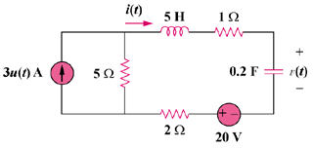

40 V

6u(t) A

Figure 8.84
For Prob. 8.36.

